St. Petersburg:
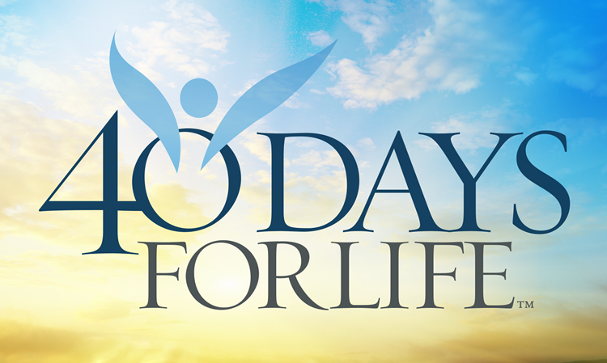
Please join us for our Diocesan-sponsored 40 Days for Life Prayer Campaign to be held September 28 through November 6. 40 Days for Life involves prayer for an end to abortion, fasting and a 40 Day Vigil in front of a local abortion center. Our vigil will be held in front of All Women’s Health Center at 4131 Central Ave, St. Petersburg. Please consider coming out to pray during this campaign. You can sign up at 40daysforlife.com/st.petersburg or contact Scott Mahurin at 727-481-3354, FloridaPrebornRescue@yahoo.com
Everyone who is willing to maintain a peaceful, prayerful presence is welcome.

Tampa:

Please join us for our Diocesan-sponsored 40 Days for Life Prayer Campaign to be held September 28 through November 6. 40 Days for Life involves prayer for an end to abortion, fasting and a 40 Day Vigil in front of a local abortion center. Our vigil will be held in front of Tampa Women’s Health Center, 2010 E. Fletcher Ave, Tampa. Please consider coming out to pray during this campaign. You can sign up at 40daysforlife.com/Tampa or contact Alex Franklin at 813-956-3709, ARFranklin4life@gmail.com
Everyone who is willing to maintain a peaceful, prayerful presence is welcome.

Clearwater:

Please join us for our Diocesan-sponsored 40 Days for Life Prayer Campaign to be held September 28 through November 6. 40 Days for Life involves prayer for an end to abortion, fasting and a 40 Day Vigil in front of a local abortion center. Our vigil will be held in front of Women’s OBGYN Center, 28960 US 19 N #110, Clearwater. Please consider coming out to pray during this campaign. You can sign up at 40daysforlife.com/Clearwater or contact Jane Lupia at ClearwaterFl40dfl@gmail.com
Everyone who is willing to maintain a peaceful, prayerful presence is welcome.

