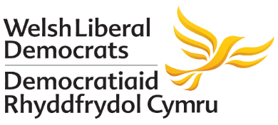

Ken Skates AM
Minister for Economy and Transport
Welsh Government
5th Floor
Tŷ Hywel
Cardiff Bay
CF99 1NA
Kirsty Williams AM
Assembly Member for Brecon and Radnorshire
4 Watergate
Brecon
Powys
LD3 9AN

Dear Ken,

I am writing following your statement on 21st May on the ‘Global Centre of Rail Excellence in Wales’, which could be an exciting development for Wales.

While the project clearly has national significance, my focus in this letter is on what it would mean for the local communities in Brecon and Radnorshire so close to the proposed location.

I was grateful for the clear message that the Joint Venture Agreement will be “consulting widely with the local community and other stakeholders on the proposals prior to the planning submission.” It is vital that the interests of local communities are taken into account. Of course I will be happy to help raise awareness of any consultation within the communities I represent.

Inevitably with a project of this scale there is a need to consider any potential disruption. This could include things like noise and vibrations, air quality, road traffic, and implications for the nearby environment. I understand issues like these have been considered in the planning so far, and I trust they will continue to be considered if and when the project moves forward.

Avoiding and minimising any potential disruption is important because I believe the centre could bring real benefits for local communities.

Of course the creation of jobs would be extremely welcome. Your statement estimated that it could see around 400 people in the construction phase and upwards of 150 people in permanent roles when fully operational, with “considerable” future opportunities. I would be grateful for any information you could provide on the anticipated skill levels of these roles.

The facility would represent a valuable source of information and data which could be of huge interest to the education sector, including to local providers of education and training. I hope that as plans are taken forward they can be joined up with the needs of these providers.

The facility would also draw people to the area, for example through the presence of visiting engineers. This I’m sure will be of interest to local businesses in the hospitality sector, who could expect an increase in customers.
I also want to mention the potential for investment in broadband. A facility of this nature would of course require high quality connection, which I would expect would require significant investment in infrastructure.

For many residents near the proposed location, getting fast and reliable access to broadband has proved extremely frustrating. To me, the process of connecting the facility to high quality broadband would seem to represent an opportunity to improve residential broadband in the surrounding area.

I would be grateful if you could provide an update on whether this is feasible and worth exploring. I have also copied Lee Waters AM into this email.

Thank you again for the update you provided earlier this week. I trust that as the project continues its development the communities I represent in the Upper Swansea Valley will be consulted, and their interests will be taken into account. This will help ensure that the project would not only provide potential benefits to Wales as a whole, but would provide potential benefits to the local communities surrounding the facility.

I look forward to your response on the issues I have raised in this letter.

Yours sincerely

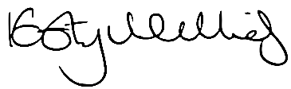
Kirsty Williams
Assembly Member for Brecon and Radnorshire

CC: Lee Waters, Deputy Minister for Economy and Transport

