What others have said about what they are most grateful for from the Spiritual Exercises in Daily Life – SEEL…

“The Spiritual Exercises helped me to feel the Passion for the first time in my life. I prayed and lived the Passion with Christ”.

“The Ignatian retreat taught me how to pray in ways I had not done before. Discernment in my life became clear; these practices result in powerful, positive emotional experiences. “.
“For any one that is looking to deepen their personal spirituality and relationship with Jesus, the Ignatian Spiritual Exercises represent an ideal opportunity. The experiences of personal prayer and scripture reading, as well as dialogue with others making the same journey, will lead to a greater awareness of God’s love for each of us as well as our role during our earthly time”.
“The signal grace for me was realizing that every moment, person, place and thing is from God and is Sacred and Holy: Seeing God in everything. I will never see God the same after this and will never take Him for granted".
Contact: Harriet Learson Ph.D., Facilitator
email: info@st-raphaels.com

Anima Christi

Soul of Christ, Sanctify me
Body of Christ, save me
Blood of Christ, inebriate me.
Water from the side of Christ wash me
Passion of Christ strengthen me.
O good Jesus hear me
Within Thy wounds, hide me
Suffer me not to be separated from Thee
From the malignant enemy, defend me.
In the hour of death, call me, and bid me come to Thee
That with thy Saints
I may praise Thee
Forever and ever.
Amen

St Ignatius loved this prayer

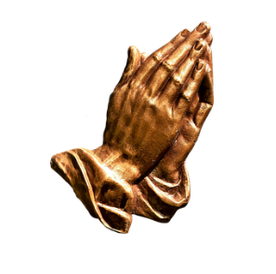
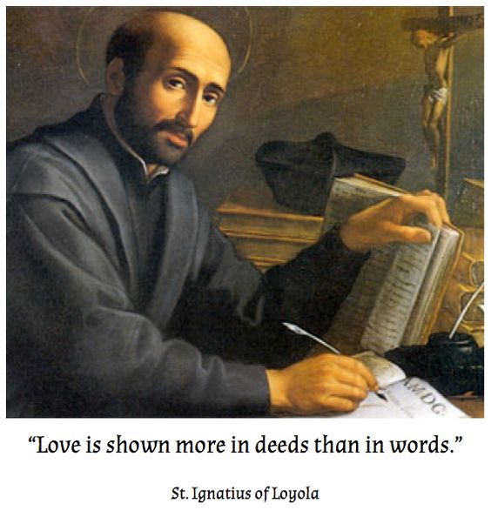

The Spiritual
Exercises of
St. Ignatius of Loyola

An Annotation 19
Retreat

SEEL: Spiritual Exercises in
Everyday Life

St. Raphael Church
Saint. Petersburg FL

Spiritual Exercises of St. Ignatius
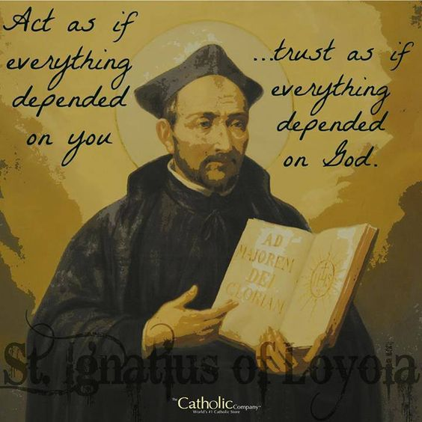
Are You taking time to grow spiritually?
Do you find it difficult to take time away for a retreat?
The Spiritual Exercises are a compilation of meditations, prayers and contemplative practices developed by St. Ignatius of Loyola to help people deepen their personal relationship with God.
For centuries the Exercises were most commonly given as a “long retreat’ of about 30 days in solitude and silence. Today there has been a renewed emphasis on the Spiritual Exercises as a program for lay people who can do it in their daily life which is done over a longer period of time and ideally timed to correlate with the liturgical year. It is a way for busy people to grow deeply in their relationship with, and commitment to, Jesus Christ.
This form of retreat involves giving time each day to prayer, committing to the method of the Spiritual Exercises.
SEEL will be offered at St. Raphael’s from October into May. Small groups of 6-8 persons will be led through 32 weekly sessions. Two meeting times will be available; one in the evening and one in the morning.
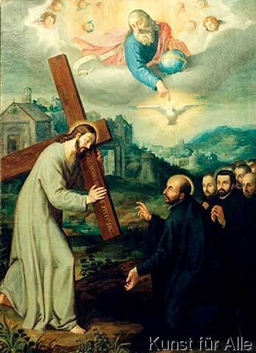
PRAYER
Persons making SEEL (Spiritual Exercises in Everyday Life) will have a personal Ignatian Prayer Guide / Spiritual Director who will meet with them in private sessions every other week allowing flexibility for a convenient time and place.
In the tradition of Ignatian spirituality, the retreat focuses on the life, teachings, death and resurrection of Jesus through a prayerful encounter with Scripture. The Ignatian principle of ‘finding God in all things” lies at the heart of the retreat.
Time is needed to prepare for this prayer experience and to be evaluated as to a personal readiness for this commitment at this time in your life.
If you feel the Lord is calling you to this kind of spiritual journey, please contact the facilitator on the back page of this brochure to schedule an initial interview. Interviews will take place between July 1st to September 15th.
Fees for a group weekly meeting and twice monthly spiritual direction will be discussed upon registration.

