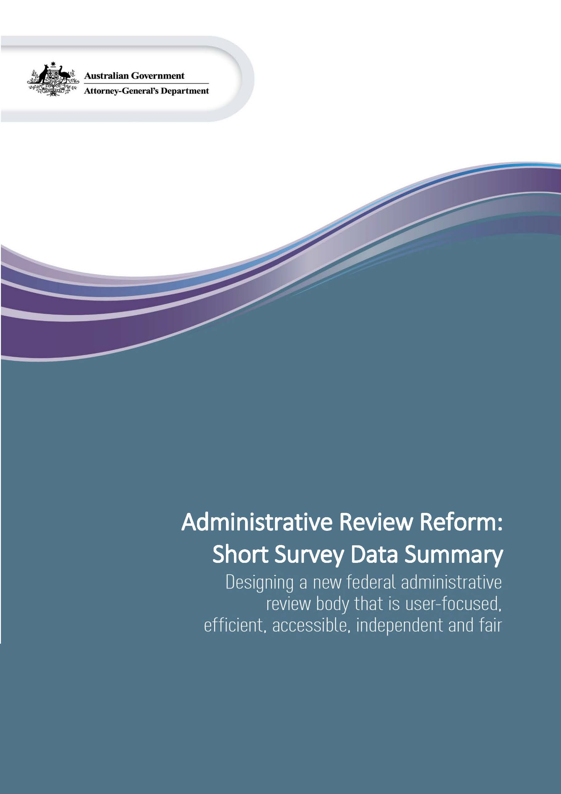

Table of Contents
Demographics 4
Engagement with the AAT 4
Question: what best describes your engagement with the AAT? 4
Location 5
Question: what state or territory are you from? 5
Diversity indicators 6
Question: do you identify as a person of Aboriginal or Torres Strait Islander descent? 6
Question: do you identify as a person with a disability? 7
Question: are you from a culturally or linguistically diverse background? 8
Question: what type(s) of matter(s) have you either sought review for, or represented, or supported a person to seek review of in the AAT? 9
Survey Questions 10
Question: in your opinion, what are the most important elements of federal administrative review? 10
Question: How important are the following skills and qualifications for a member of the new body? 11
Question: In your opinion, for how many years should a member be appointed to the new body? 12
Question: How important do you believe the following qualities are for tribunal members? 13
Question: Imagine you were planning to apply for review to the new body. How likely would you be to use the following ways to apply? 14
Question: Do you think that applicants to the new body should be required to provide a short statement setting out why the applicant believes a decision is wrong (statement of reasons) when making an application for review? 15
Question: When should the new body allow private hearings or decide that information or documents shouldn’t be published? 16
Question: Should dispute resolution be available across all types of matters in the new body? 17
Question: Imagine you have applied for review with the new body. How easy or difficult would you find it to engage in the tribunal proceedings through each of the following methods? 18
Question: What would most help you understand the reasons for the tribunal's decision? 19
Question: What would be your preferred method(s) of receiving a decision made by the tribunal? 20
Question: Should people and organisations involved in a review (including government organisations) need permission to have a lawyer represent them? 21
Question: How important do you think the following services and supports are to ensure the new body is accessible? 22
Question: Do you identify as an applicant who might need one or more of the services or supports listed in the question above? 23

Demographics
This section of the survey asked questions about the respondents, including in relation to their interaction with the Administrative Appeals Tribunal (AAT) and key diversity indicators.

Engagement with the AAT

Question: What best describes your engagement with the AAT?
Selection | Total | Percent
I am an AAT user (I have or had an application for review in the AAT) | 35 | 12.20%
I represent or support AAT users (people who have an application for review in the AAT) | 83 | 28.92%
I work or have worked at the AAT | 118 | 41.11%
I have never engaged directly with the AAT | 51 | 17.77%

Location

Question: What state or territory are you from?
Selection | Total | Percent
NSW | 86 | 29.97%
Vic | 77 | 26.83%
Qld | 46 | 16.03%
WA | 31 | 10.80%
SA | 20 | 6.97%
Tas | 7 | 2.44%
ACT | 18 | 6.27%
NT | 2 | 0.70%

Diversity indicators

Question: Do you identify as a person of Aboriginal or Torres Strait Islander descent?
Selection | Total | Percent
Yes | 4 | 1.39%
No | 272 | 94.77%
Prefer not to answer | 10 | 3.48%
Not Answered | 1 | 0.35%

Question: Do you identify as a person with a disability?
Selection | Total | Percent
Yes | 40 | 13.94%
No | 234 | 81.53%
Prefer not to answer | 13 | 4.53%

Question: Are you from a culturally or linguistically diverse background?
Selection | Total | Percent
Yes | 71 | 24.74%
No | 204 | 71.08%
Prefer not to answer | 11 | 3.83%
Not Answered | 1 | 0.35%

Question: What type(s) of matter(s) have you either sought review for, or represented, or supported a person to seek review of in the AAT?

Note: Users had the option to select multiple choices.

Selection | Total
Migration or refugee matter | 33
Social Services | 23
National Disability Insurance Scheme | 46
Freedom of Information | 18
Security | 1
Taxation | 17
Workers Compensation | 19
Veterans | 8
Citizenship | 16
Other | 21
Not Answered | 1689

Survey Questions

Question: In your opinion, what are the most important elements of federal administrative review?
Survey respondents were asked to rank how important elements of federal administrative review were, as set out below, from 1 to 6, where 1 is the most important, and 6 is the least important. Respondents were not required to rank all elements. Some elements have a higher number of respondents than others.
Each skill or qualification was ranked on a scale 1 to 6 (ie. respondents could not rank all elements equally).
Data summary
 | 1 | 2 | 3 | 4 | 5 | 6 | Not answered
That it is fair | 62.72%  (180) | 15.33%  (44) | 9.41%  (27) | 5.23%  (15) | 3.83%  (11) | 1.74%  (5) | 1.74%  (5)
That it is easy to access | 5.57%  (16) | 27.87%  (80) | 25.78%  (74) | 20.21%  (58) | 11.15%  (32) | 3.83%  (11) | 5.57%  (16)
That it is cheap | 3.83%  (11) | 5.23%  (15) | 10.80%  (31) | 14.63%  (42) | 17.42%  (50) | 36.24%  (104) | 11.85%  (34)
That it uses simple and informal procedures | 5.92%  (17) | 12.89%  (37) | 18.47%  (53) | 24.39%  (70) | 20.56%  (59) | 10.1%  (29) | 7.67%  (22)
That it promotes public trust and confidence in decision-making | 11.85%  (34) | 19.86%  (57) | 13.59%  (39) | 15.33%  (44) | 17.42%  (50) | 16.72%  (48) | 5.23%  (15)
That it improves government decision-making | 9.06%  (26) | 17.07%  (49) | 19.86%  (57) | 11.5%  (33) | 18.47%  (53) | 18.82%  (54) | 5.23%  (15)
This graph shows, by percentage, how people ranked each element of administrative review from 1 to 6.

Question: How important are the following skills and qualifications for a member of the new body?
This question asked respondents to rank a range of skills and qualifications for members of the new body to have as very important, important, moderately important, slightly important or not at all important.
Each skill or qualification was ranked on the scale of very important to not at all important (ie. respondents could rank all skills as very important).
Data summary
This graph shows, by percentage, how respondents ranked various skills and qualifications from very important to not at all important.
 | Very important | Important | Moderately important | Slightly important | Not at all important | Not answered
Legal qualifications | 43.9%  (126) | 25.08%  (72) | 20.91%  (60) | 4.53%  (13) | 5.57%  (16) | 0%  (0)
Qualifications in a relevant field | 33.1%  (95) | 36.59%  (105) | 17.07%  (49) | 6.27%  (18) | 6.62%  (19) | 0.35%  (1)
Experience in a relevant field | 49.83%  (143) | 31.36%  (90) | 14.29%  (41) | 2.44%  (7) | 2.09%  (6) | 0%  (0)
Decision-making and reasoning | 86.76%  (249) | 11.15%  (32) | 0.7%  (2) | 1.05%  (3) | 0.35%  (1) | 0%  (0)
Writing and communication | 74.22%  (213) | 21.25%  (61) | 3.14%  (9) | 1.39%  (4) | 0%  (0) | 0%  (0)
Ability to conduct hearings | 66.9%  (192) | 25.78%  (74) | 5.23%  (15) | 1.05%  (3) | 0%  (0) | 1.05%  (3)
Lived experience | 25.44%  (73) | 24.74%  (71) | 23%  (66) | 17.42%  (50) | 9.06%  (26) | 0.35%  (1)

Question: In your opinion, for how many years should a member be appointed to the new body?
This question asked respondents to consider how many years members should be appointed to the new body. 60% of respondents said that members should be appointed for 4-5 years.

Selection | Total | Percent
3 years or less | 50 | 17.42%
4-5 years | 171 | 59.58%
6-7 years | 40 | 13.94%
I'm not sure | 24 | 8.36%
Not Answered | 2 | 0.70%

Question: How important do you believe the following qualities are for tribunal members?
This question asked respondents to rank how important a range of qualities are for tribunal members, from very important to not at all important.
Each skill or qualification was ranked on the scale of very important to not at all important (ie. respondents could rank all skills as very important).
Data summary
This graph shows, by percentage, how people ranked various qualities for members of tribunals from very important to not at all important.
 | Very important | Important | Moderately important | Slightly important | Not at all important | Not answered
Independence | 80.14%  (230) | 14.63%  (42) | 4.53%  (13) | 0.35%  (1) | 0.35%  (1) | 0%  (0)
Impartiality | 94.08%  (270) | 5.23%  (15) | 0.7%  (2) | 0%  (0) | 0%  (0) | 0%  (0)
Integrity | 94.77%  (272) | 4.18%  (12) | 1.05%  (3) | 0%  (0) | 0%  (0) | 0%  (0)
Fairness | 93.73%  (269) | 5.57%  (16) | 0.7%  (2) | 0%  (0) | 0%  (0) | 0%  (0)
Respect for the law | 82.58%  (237) | 16.03%  (46) | 1.39%  (4) | 0%  (0) | 0%  (0) | 0%  (0)
Empathy | 79.44%  (228) | 16.38%  (47) | 3.48%  (10) | 0.35%  (1) | 0.35%  (1) | 0%  (0)
Professionalism | 60.63%  (174) | 24.04%  (64) | 10.8%  (31) | 3.48%  (10) | 0.7%  (2) | 0.35%  (1)

Question: Imagine you were planning to apply for review to the new body. How likely would you be to use the following ways to apply?
This question set out a series of ways that a person could apply for review of a decision by the new body and asked respondents to rank how likely they would be to use each method of lodgement from very likely to very unlikely.
Each method was ranked on the scale of very likely to not very likely (ie. respondents could rank all methods as very likely).
Data summary
This graph shows, by percentage, how likely or unlikely respondents considered they would be to use various methods of filing an application for review.
 | Very likely | Likely | Neither likely or unlikely | Not likely | Very unlikely | Not answered
Filling out an online form | 81.88%  (235) | 12.20%  (35) | 3.48%  (10) | 1.05%  (3) | 0.35%  (1) | 1.05%  (3)
Sending an email | 41.11%  (118) | 34.15%  (98) | 10.45%  (30) | 7.67%  (22) | 2.79%  (8) | 3.83%  (11)
Making a phone call | 24.04%  (69) | 20.21%  (58) | 19.51%  (56) | 20.56%  (59) | 13.24%  (38) | 2.44%  (7)
Completing a written application in-person | 5.23%  (15) | 9.76%  (28) | 13.94%  (40) | 33.80%  (97) | 33.80%  (97) | 3.48%  (10)
Mailing a written application | 7.32%  (21) | 11.15%  (32) | 13.94%  (40) | 27.53%  (79) | 36.24%  (104) | 3.83%  (11)

Question: Do you think that applicants to the new body should be required to provide a short statement setting out why the applicant believes a decision is wrong (statement of reasons) when making an application for review?
This question sought respondents’ views as to whether an applicant should have to provide a statement of reasons as to why a decision was wrong when they may an application for review.
Selection | Total | Percent
Yes | 216 | 75.26%
No | 45 | 15.68%
I’m not sure | 26 | 9.06%
Not Answered | 0 | 0.00%

Question: When should the new body allow private hearings or decide that information or documents shouldn’t be published?
This question sought respondents’ views as to whether the new body should allow private hearings only in circumstances, or whether all information, hearings and documents should be public or private.
Selection | Total | Percent
Never | 43 | 14.98%
When a person requests that their matter be heard in private or information about them not be published | 205 | 71.43%
All hearings, information and documents should be private | 34 | 11.85%
Not Answered | 5 | 1.74%

Question: Should dispute resolution be available across all types of matters in the new body?
This question sought respondents’ views as to whether alternative dispute resolution should be available across all types of matters.
Selection | Total | Percent
Yes | 216 | 75.26%
No | 41 | 14.29%
I'm not sure | 29 | 10.10%
Not Answered | 1 | 0.35%

Question: Imagine you have applied for review with the new body. How easy or difficult would you find it to engage in the tribunal proceedings through each of the following methods?
This question sought respondents’ views as to how easy or difficult they would find it to engage with the new body, including through providing written submissions, participating through various electronic means or participating in person, from very easy to very difficult.
Each engagement was ranked on the scale of very easy to very difficult (ie. respondents could rank every engagement as very easy).
Data summary
 | Very easy | Easy | Neutral | Difficult | Very difficult | Not answered
Providing written submissions | 40.07%  (115) | 31.36%  (90) | 15.33%  (44) | 10.1%  (29) | 1.74%  (5) | 1.39%  (4)
Participating via telephone | 43.55%  (125) | 29.27%  (84) | 14.63%  (42) | 8.71%  (25) | 2.79%  (8) | 1.05%  (3)
Participating via video link | 43.55%  (125) | 31.36%  (90) | 14.29%  (41) | 6.97%  (20) | 2.79%  (8) | 1.05%  (3)
Participating in person | 37.98%  (109) | 32.4%  (93) | 14.63%  (42) | 7.67%  (22) | 5.92%  (17) | 1.39%  (4)
This graph shows, by percentage, how easy or difficult respondents would find it to engage with the new body through various means.

Question: What would most help you understand the reasons for the tribunal's decision?
This question asked respondents to rank from 1 to 4 what would be most helpful for them in understanding the reasons for the new body’s decision in their matter. The selections included where the reasons are written in plain English, the reasons focus on the key evidence the decision maker has relied on to make the decision, the reasons include a detailed examination of all evidence and where the reasons are short.
Each selection was ranked on a scale 1 to 4 (ie. respondents could not rank all elements equally).
Data summary
This graph shows, by percentage, how people ranked the various options in relation to what would assist them to understand a decision of the new body in their matter.
 | 1 | 2 | 3 | 4 | Not answered
The reasons focus on key evidence | 28.22%  (81) | 40.07%  (115) | 25.78%  (74) | 5.23%  (15) | 0.07%  (2)
The reasons include a detailed examination of all evidence | 25.44%  (73) | 23.34%  (67) | 29.62%  (85) | 21.25%  (61) | 0.35%  (1)
The reasons are in plain English | 43.55%  (125) | 26.13%  (75) | 27.18%  (78) | 2.09%  (6) | 1.05%  (3)
The reasons are short | 2.44%  (7) | 9.76%  (28) | 16.38%  (47) | 69.34%  (199) | 2.09%  (6)

Question: What would be your preferred method(s) of receiving a decision made by the tribunal?
This question sought respondents’ views on how they would prefer to receive a decision made by the new body, including orally, a brief written summary after the hearing, or detailed written statement after the hearing.
Note: Users had the option to select multiple choices.
Selection | Total
Orally (i.e. the member says what their decision is at the hearing) | 69
Brief written summary after the hearing | 95
Detailed written statement after the hearing | 206
Not Answered | 3

Question: Should people and organisations involved in a review (including government organisations) need permission to have a lawyer represent them?
This question sought respondents’ views on whether participants in a review should need to seek permission to have a lawyer represent them. 58% of respondents answered ‘no’.
Selection | Total | Percent
Yes | 92 | 32.06%
No | 167 | 58.19%
I’m not sure | 27 | 9.41%
Not Answered | 1 | 0.35%

Question: How important do you think the following services and supports are to ensure the new body is accessible?
This question asked respondents to rank a range of services and supports in terms of how important they are in ensuring the new body is accessible to all participants.
Each accessibility option was ranked on the scale of very important to not important at all (ie. respondents could rank every accessibility as very important).
Data summary
 | Very important | Important | Moderately important | Slightly important | Not at all important | Not answered
Legal assistance | 56.1%  (161) | 27.53%  (79) | 10.8%  (31) | 3.48%  (10) | 1.74%  (5) | 0.35%  (1)
Interpreter | 84.32%  (242) | 12.89%  (37) | 2.09%  (6) | 0.35%  (1) | 0.35%  (1) | 0%  (0)
Closed hearings | 21.95%  (63) | 27.18%  (78) | 24.04%  (69) | 12.54%  (36) | 13.24%  (38) | 1.05%  (3)
Withhold personal information | 29.97%  (86) | 32.06%  (92) | 24.74%  (71) | 7.67%  (22) | 4.88%  (14) | 0.7%  (2)
Reasonable adjustments | 77.7%  (223) | 16.72%  (48) | 4.88%  (14) | 0.35%  (1) | 0%  (0) | 0.35%  (1)
Tribunal outreach | 38.33%  (110) | 34.15%  (98) | 17.42%  (50) | 6.62%  (19) | 2.79%  (8) | 0.7%  (2)
Cultural safety | 52.26%  (150) | 27.18%  (78) | 12.89%  (37) | 4.88%  (14) | 2.44%  (7) | 0.35%  (1)
This graph shows, as a percentage, how respondents ranked a variety of services and supports in terms of their importance in ensuring the new body is accessible, from very important to not at all important.

Question: Do you identify as an applicant who might need one or more of the services or supports listed in the question above?
This question asked respondents to indicate whether the identified as an applicant who might need one or more of the support services listed in the previous question, to contextualise those responses.
Selection | Total | Percent
Yes | 67 | 23.34%
No | 203 | 70.73%
I’m not sure | 15 | 5.23%
Not Answered | 2 | 0.70%

