User Manual of CY-12c Oxygen Analyzer

Hangzhou Jiachang Electronic Technology Co., Ltd
Jiande City Tongda Electronic Control Equipment Factory

User Manual of CY-12c Oxygen Analyzer

Equipped with a 6F-22 9V battery and high precision Oxygen sensor, CY-12C Oxygen detector uses completely integrated circuits which make the meter easier to use and much more portable.CY-12C is suitable for monitoring of oxygen concentration under various scenarios, such as mining, ship cabins, instruments of chemical industry, exhausting of internal-combustion engine, flue gas, food supplies, and storage of fruit and vegetables. It can also monitor oxygen concentration during the experiment of photosynthesis of crops and plants.

- Technical Specification：

- Range： 0-100％
- Accuracy degree： 3
- Minimum oxygen content：0.1%；
- Response time：10s（90%）；
- Electrode lifetime： one year or more
- Working Environment： temperature：-10~50℃； Humidity：≤85%RH。
- Power：6F22 9v
- Size：126mm×69mm×25mm。
- Weight：150

- Operation Instructions
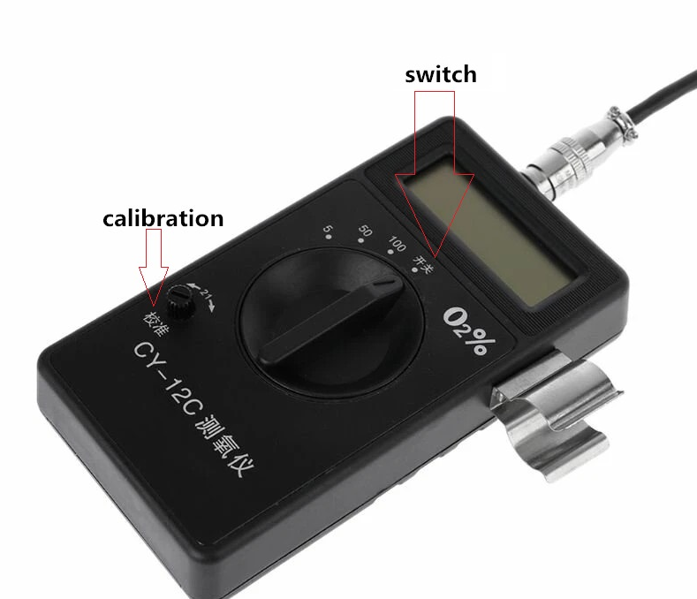
Turn the wave band switch to 50%, connect the air absorbing ball with one mouth of the oxygen electrode, press the ball in order to absorb fresh air, and then do calibration after 3-5 minutes to make the meter stable shows 21.0%.Survey can be started after that. 3 minutes later, the meter will show a stable index, that is the current Oxygen Concentration If the survey value is below 5% or above 50%, switch over to another range.

1. Close-by survey: use the rubber tube to connect the air absorber which has absorbent cotton with one mouth of the oxygen electrode, and then connect the ball with another mouth of the oxygen electrode. Finally, connect air absorber with the air vent, press the ball, read the numbers when it becomes stable.

2.Long-distance survey: According to the testing environment, extend the air absorber (with absorbent cotton) with rubber tube, put it into the testing environment slowly, make sure you stay away from water or any liquid. When it is in the proper surroundings, press the ball repeatedly so that the air can enter the oxygen sensor quickly and completely. Read the numbers when they become stable.

Attention:
- When LDBAT or Minus shows at the right corner of the meter, it means battery low and needs to change battery or recharged. Please unscrew the back shield, and then change 6F－22 battery.
- Please avoid high temperature, moisture, and violent shakes. The Analyzer should be sorted in a dry place (Please use rubber plug or rubber tube to seal mouths of the oxygen electrode to extend its lifetime)
- After air is absorbed, and 21.0% doesn’t show stably, the user should check the connection part, to avoid loose connections.
- If the survey value is unstable, please press the ball several times.
- If the meter doesn’t function properly, and cannot be adjusted to 21.0%, there could be something wrong with the meter or oxygen electrode, please send it back to our factory for repairs
- Warranty is one-year. There will be no extra charge for repairs due to quality issues of our equipment. The meter is an electrochemistry instrument, produced under the JJG365 – 98 standards. Equipment should be sent back to the factory for a routine check up after 12 – 18 months of usage.

●Attachment： Oxygen content/above sea level ,for reference

Height (m) | 02% | Height  (m) | 02% | Height  (m) | 02%
0 | 20.95 | 3500 | 13.72 | 7000 | 8.59
500 | 19.80 | 4000 | 12.78 | 7500 | 7.96
1000 | 18.75 | 4500 | 11.94 | 8000 | 7.44
1500 | 17.60 | 5000 | 11.21 | 8500 | 6.91
2000 | 16.55 | 5500 | 10.48 | 9000 | 6.39
2500 | 15.61 | 6000 | 9.85 | 9500 | 5.97
3000 | 14.67 | 6500 | 9.22 | 10000 | 5.45

Hangzhou Jiachang Electronic Technology Co., Ltd
Jiande City Tongda Electronic Control Equipment Factory
ADD: NO.92, Second Bridge, Mei city, Jiande, Zhejiang Province PC: 311604
Phone: 0571- 64148602
0571-64143561

