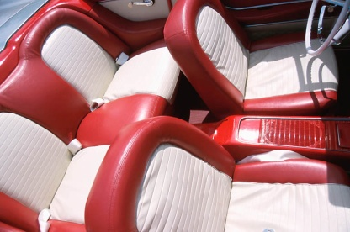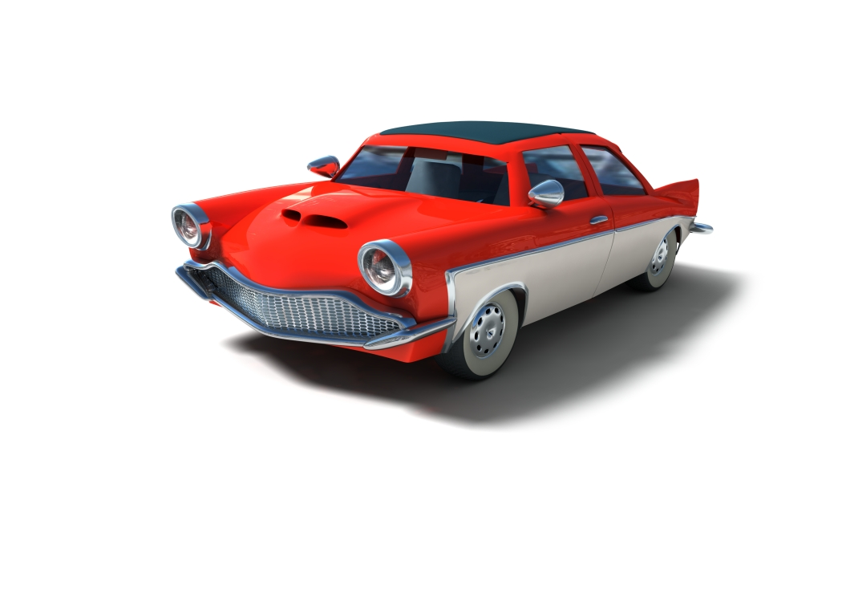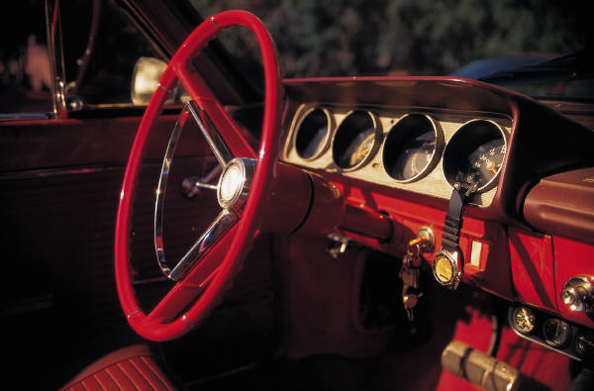

$18,000

Contact [Name] at (555) 555-0125

Inside color/fabric type  
Power locks, windows  
Air conditioning

Odometer mileage  
Transmission type  
Engine size

Sound system   
General condition Outside color

Name

(555) 555-0125

FOR SALE

Made in Office 2007 for office2007.com

Name

(555) 555-0125

Name

(555) 555-0125

Name

(555) 555-0125

Name

(555) 555-0125

Name

(555) 555-0125

Name

(555) 555-0125

Name

(555) 555-0125

Name

(555) 555-0125

Name

(555) 555-0125