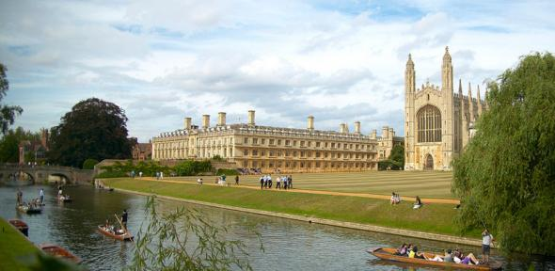
UPDATED INVITATION
TO A TECHNOLOGY WORKSHOP
IN CAMBRIDGE, ENGLAND
We invite you to a workshop in Cambridge, England, on the Medial Object and the Medial Axis Transformation (MAT) and their applications, which TranscenData Europe Ltd is organising on Thursday and Friday, 9-10 October 2014.

A DRAFT OUTLINE PROGRAMME for the workshop is now available here.
We have received an encouraging level of interest and several offers of presentations.
Deadline for abstracts is 31 August. After which, we will finalise the programme.

VENUE AND TIMING
This Workshop is timed to be immediately before the SANDIA IMR 2014 in London: http://www.sandia.gov/imr/
12-15 October, with the expectation that some attendees of this workshop and the IMR will have an interest in both events. The workshop will be held in The Royal Cambridge hotel with a dinner in Queens’ College Old Hall on the Thursday evening. It will start early on Thursday 9th October, so we recommend arrival by Wednesday evening, and end on Friday afternoon, in time for attendees to travel to London. We would encourage everyone to stay over at least till Saturday 11th October to enjoy being a tourist in Cambridge. We have secured a bed & breakfast rate of £95 per person incl. VAT in The Royal Cambridge hotel together with a block booking, which will be held for us until 1st August 2014.
We also have booked the Old Hall in Queens’ College http://www.quns.cam.ac.uk/queens/images/OldHall.html for dinner on Thursday 9th October and are delighted to announce that Professor Jim Woodhouse, a Cambridge University engineering academic http://www2.eng.cam.ac.uk/~jw12/ has agreed to present a talk after dinner over coffee on “When does a structure become an instrument?”.

MAT AND MO
The Medial Axis Transformation (MAT) was the subject of intensive research at Queen’s University Belfast in the 80’s and was then developed by TranscenData Europe Ltd from 2004 onwards in the form of Medial Object (MO) computation. In recent years the Medial Object has become a key geometric reasoning technology in several EU and TSB supported projects, including VIVACE, CRESCENDO, SILOET, ANSD, SimOD and GHandI. Applications of TranscenData’s MO have also been explored in several academic research projects. We are aware that there are also several other groups working on MAT methods and applications.
The aim of this workshop is to bring together individuals and groups who are active or interested in the computation and applications of the Medial Object or the Medial Axis Transformation. To encourage a full exchange of ideas, it will be an informal event with no published proceedings, with attendees able to present last minute results. It will be up to each presenter to decide whether to distribute any presentation material. Attendees will be limited to 50, to also encourage discussion. Please suggest others who might be interested to hear about this workshop. The last session of the Workshop will be a plenary discussion, facilitated by Dr Malcolm Sabin.

BOOKING FORM
The Workshop booking form can be found here and make your reservation at The Royal Cambridge Hotel. Hotels in Cambridge are notoriously booked up, so early booking is recommended.

ORGANISING COMMITTEE
Dr Geoffrey Butlin, CEO, TranscenData Europe Ltd
Mark Gammon, Product Manager, TranscenData Europe Ltd
Henry Bucklow, Senior Project Engineer, TranscenData Europe Ltd
Dr Malcolm Sabin, Numerical Geometry Ltd

TOURIST OPPORTUNITIES
Cambridge is less than an hour by train from London. Here are some tourist links:
- http://www.cambridgetouristinformation.co.uk/
- http://www.iwm.org.uk/visits/iwm-duxford
- http://www.visitlondon.com/

