FD117 Wide Rotor Tip On MO3000 Rotor Suggested Construction Method
Tools:
Metal vice, 1/8 and 5/64 drills, centering punch, power drill, 100 Watt soldering iron, file, Super Glue, Hacksaw (or alternate Dremel with metal cutting cutoff wheel), and pliers.

Disassembly & Hole Drilling Sequence:
- Place FD117 rotor in vice and crush plastic to loosen rivet holding tip
- Pry rivet from remaining plastic and remove rotor tip
- Pry MO3000 rotor tip from MO3000 by using mini screwdriver driven between rotor tip and plastic….save all MO3000 components
- Place MO3000 tip on FD117 tip with FD117 tip extended about 1/64 beyond the MO3000 tip. Mark rivet hole on FD117 tip using MO3000 tip as a template. Flip over FD 117 rotor tip and using MO3000 as a template mark the rivet hole location on the other side of FD 117 tip.
- Centerpunch for rivet hole. Centerpunch both sides of FD117 tip.
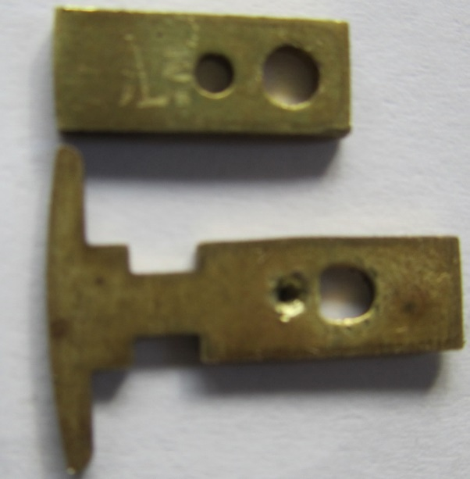
- Clean off all markings on both sides of FD117 tip.
- Place the MO3000 tip so the FD117 tip centerpunch marking is centered in the MO3000 rivet hole. Observe if the FD117 tip is extended 1/64 beyond the MO3000 tip. Do this on both sides of the FD117 tip and pick the side that has the centerpunch best positioned to give you not only the 1/64 extension but also the edges of the tips are aligned.
- Clamp tip in vice
Drill 5/64 hole in FD117 tip using the best centerpunched location
- Enlarge hole to 1/8 diameter using 1/8 drill

Cutting FD117 tip to Length:
- Use MO3000 stainless center spring electrode to determine overall length of FD117 tip
- Align stainless electrode rivet hole with new FD117 rivet hole
- Note where stainless electrode starts bending upward; mark edge of FD117 at that point
- Remove stainless electrode; extend FD117 edge mark across width of FD117 tip
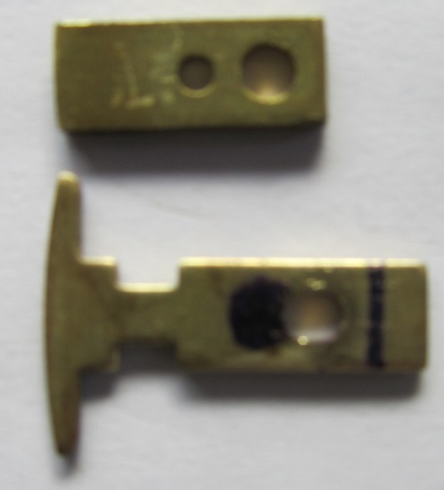
- Place FD117 tip in vice and cutoff just shy of the marking; goal is to have the stainless electrode bend freely without catching inboard end of FD117 rotor tip when assembled (hacksaw with metal blade or Dremel with cutoff wheel)

Assemble FD117 Rotor Tip/MO3000 Rotor:
- Place FD117 tip in MO3000 rotor groove; file FD117 tip edges only enough to fit very tightly…drilled rivet hole must remain centered in the tip from edges
- Above step may require small nub to be removed from MO3000 rotor groove.
- Check fit of stainless steel spring electrode by mounting in rotor groove with rivet hole aligned. Place FD117 tip on stainless electrode also with rivet hole aligned. Check to insure small gap between end of FD117 tip and start of stainless electrode bend.
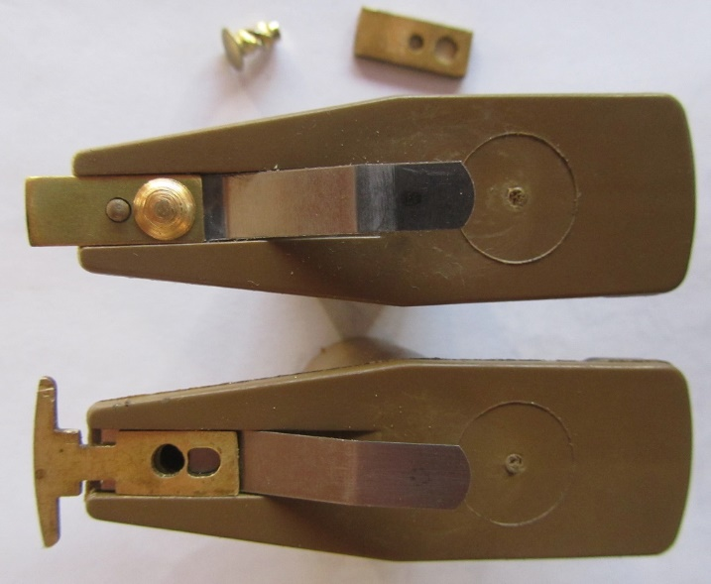
- Remove all components & start assembly by placing Super Glue in rivet hole
- Place stainless electrode in position with rivet hole aligned
- Place tip on stainless electrode with rivet hole aligned
- Press rivet partially in hole
Using pliers squeeze rivet until tip & electrode are firmly clamped to rotor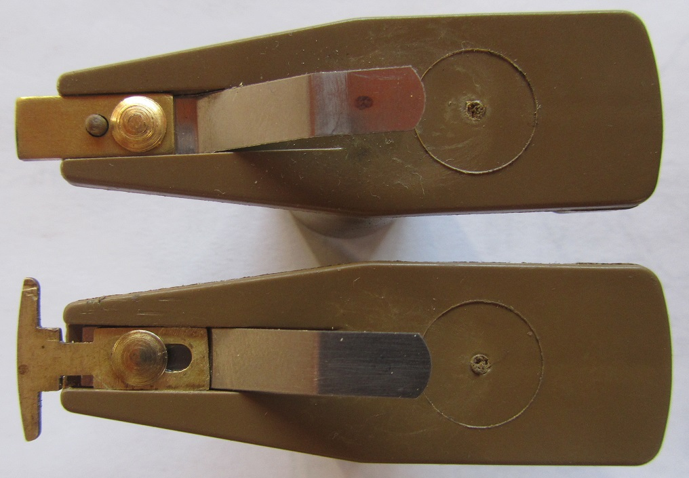
- Let stand overnight before using solder gun
Melt portion of plastic rotor into FD117 tip grooves 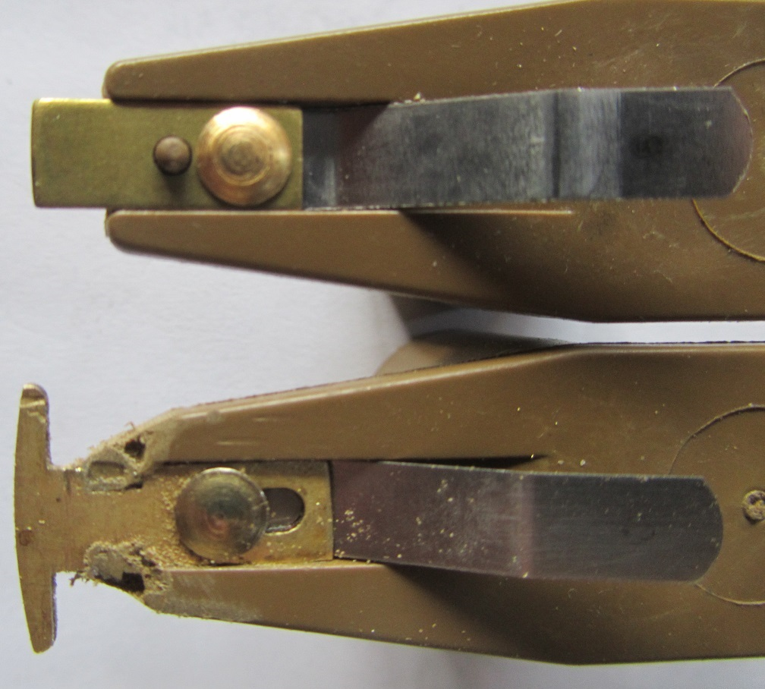
- File plastic burrs after plastic has hardened

